**Project Design Phase-II**

**Data Flow Diagram & User Stories**

|  |  |
| --- | --- |
| Date | 03 November 2022 |
| Team ID | PNT2022TMID21423 |
| Project Name | Project - A Novel Method for handwritten digit  recognition system |
| Maximum Marks | 4 Marks |

**Data Flow Diagrams:**

A Data Flow Diagram (DFD) is a traditional visual representation of the information flows within a system. A neat and clear DFD can depict the right amount of the system requirement graphically. It shows how data enters and leaves the system, what changes the information, and where data is stored.

Example: DFD Level 0 (Industry Standard)

**Example:** [**(Simplified)**](https://developer.ibm.com/patterns/visualize-unstructured-text/)

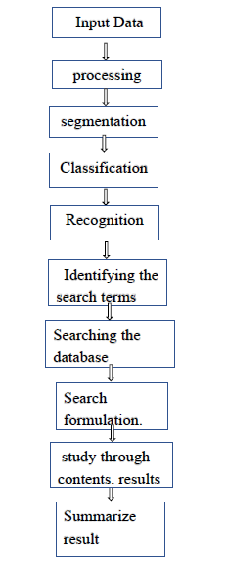

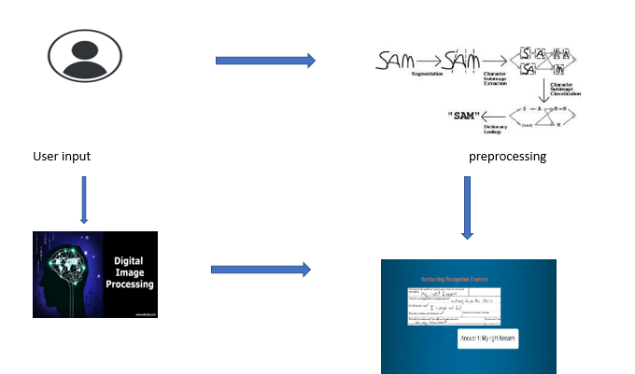

**User Stories**

Use the below template to list all the user stories for the product.

| **User Type** | **Functional Requirement (Epic)** | **User Story Number** | **User Story / Task** | **Acceptance criteria** | **Priority** | **Release** |
| --- | --- | --- | --- | --- | --- | --- |
| Customer (Mobile user) | Install application | USN-1 | As a user, I should able to install the application easily. | User can access my application through mobile /computers | High | Sprint-1 |
|  | User input image | USN-2 | As a user, I can able to upload images in app to predict the result or digit. | User can give input image | High | Sprint-1 |
|  | User requirement | USN-3 | As a user, I should decide the font size like that my requirements must be sorted out. | User can give requires needed. | Low | Sprint-2 |
|  | View result | USN-4 | As a user, I see result obtained | User can get result | High | Sprint-1 |
|  | Login | USN-5 | As a user, I can log into the application by entering email & password | Login by password | High | Sprint-1 |
| Customer Care Executive | Safe and secure |  | For users all the informations given by them must be safe and secure. |  | High | Sprint-1 |
| Administrator | Accurate result |  | Administrator must try to give accurate result. |  | High | Sprint-1 |